|  |  |
| --- | --- |
| **WC Logo.emf** | **Staff Report to the Weber County Commission**  *Weber County Planning Division* |
|  | |

****Synopsis****

****Application Information****

**Application Request:** A request, through public hearing, to approve an ordinance vacating a 10 foot public utility easement, located along the west boundary of lot 3, Fox Crossing Subdivision.

**Agenda Date: Tuesday, February 5, 2022**

**Applicant:** Eric Davis, Owner

**File Number:** EV 2021-08

****Property Information****

**Approximate Address:** 5374 N Hwy 162, Eden, UT, 84310

**Project Area:** 0.97 acres

**Zoning:** AV-3 Zone

**Existing Land Use:** Residential

**Proposed Land Use:** Residential

**Parcel ID:** 22-120-0003

**Township, Range, Section:** T7N, R1E, Section 7 Qtr Section SE

****Adjacent Land Use****

**North:** Residential **South:** Residential

**East:** Hwy 162 **West:** Residential

****Staff Information****

**Report Presenter: Tammy Aydelotte**

taydelotte@webercountyutah.gov

**801-399-8794**

**Report Reviewer:** SB

Background and Summary

The applicant has requested to vacate a 10 foot public utility easement located along the west and north lot boundaries, of lot 3, Fox Crossing Subdivision. The County Engineer has only approved vacating the easement along the west boundary, leaving the public utility easement along the northern boundary completely intact. The applicant is requesting the vacation to allow for an accessory structure closer than 10’ to the west lot boundary.

Summary of County Commission Considerations

The County Commission will need to determine if there will be any detrimental impacts caused by vacating the proposed portion of an existing public utility easement. Utah Code §17-27a-609.5 states that *“The legislative body may adopt an ordinance granting a petition to vacate some or all of a public street, right-of-way, or easement if the legislative body finds that:*

*(a) good cause exists for the vacation; and*

*(b) the public interest or any person will not be materially injured by the proposed vacation.*

Conformance to the General Plan

Vacating a portion of the identified easement is not anticipated to have a negative effect the West Central Weber General Plan.

Staff Recommendation

Staff recommends approval of the request to vacate the existing 10 foot public utility easement along the western lot boundary, leaving the entire 10’ public utility along the northern lot boundary. This recommendation for approval is subject to all review agency requirements.

The recommendation is based on the following findings:

1. Vacating the proposed public utility easement will not have a negative effect on the Ogden Valley General Plan.
2. Based on the proposed subdivision amendment, good cause exists to vacate the easement.
3. The public interest or any person will not be materially injured by the proposed vacation.

Exhibits

1. Easement Vacation Application with Narrative
2. Proposed Vacation Ordinance

Location Map

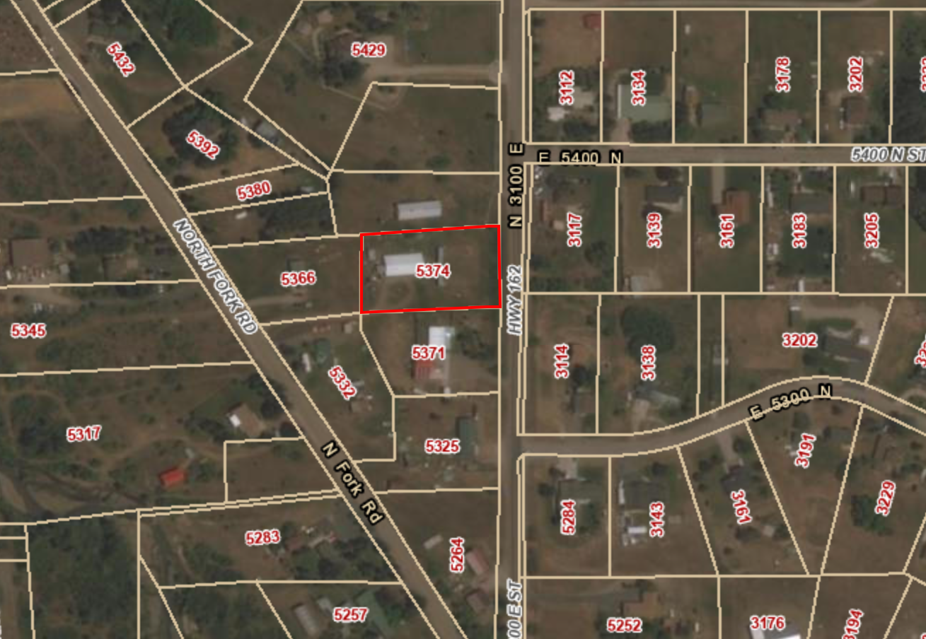

Exhibit A – Easement Vacation Application with Narrative

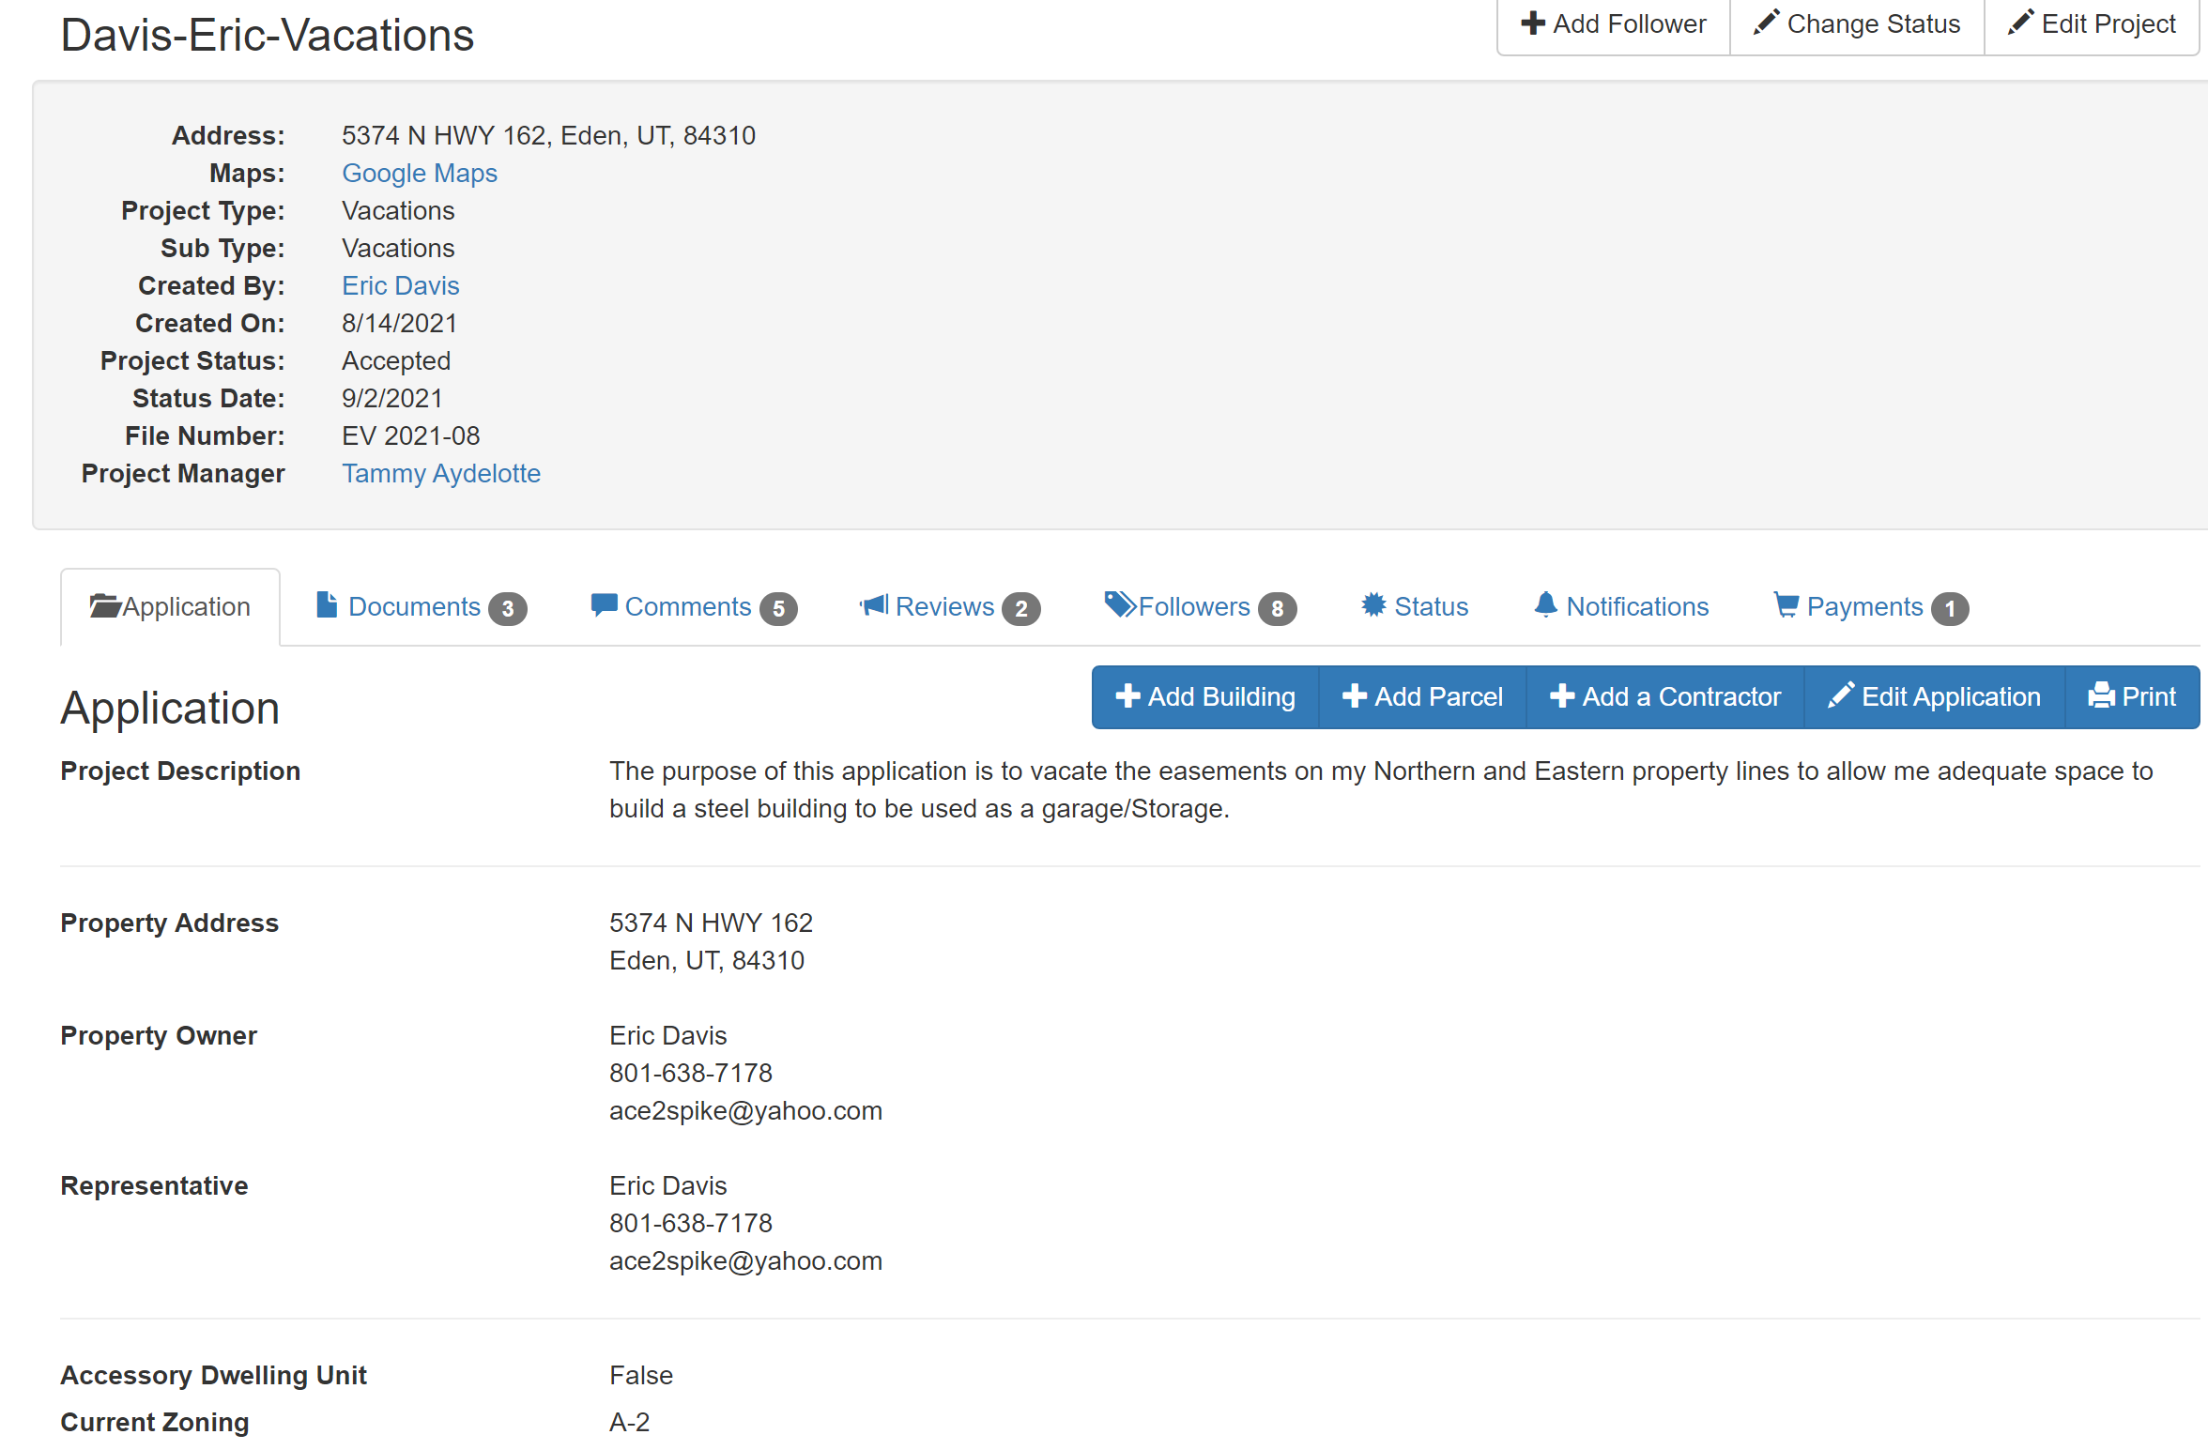

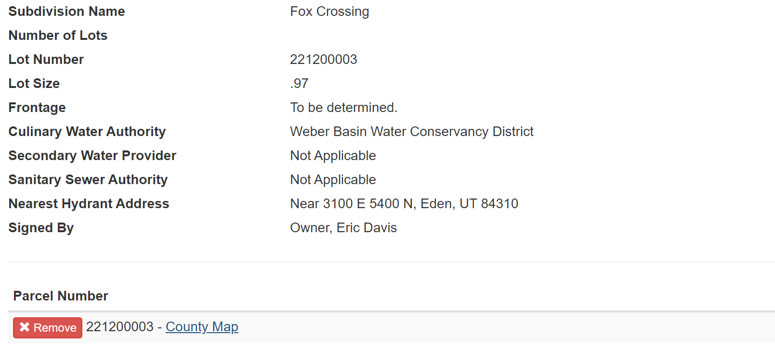

Exhibit B – Proposed Vacation Ordinance

**See NEXT PAGE**

**Ordinance No.**

**An ordinance of Weber County vacating**

**a Public utility easement in the FOX CROSSING subdivision**

**WHEREAS,** the Owner has filed a petition to vacate a ten-foot public utility easement along the west property line of lot 3, Fox Crossing Subdivision, as described in Exhibit A of this ordinance; and

**WHEREAS,** after providing proper public notice, a public hearing was held before the Weber County Commission on February 1, 2022, regarding the vacation of the public utility easement; and

**WHEREAS,** Weber County’s Engineering Department has been notified and has provided written approval of the vacation of the portion of the public utility easement; and

**WHEREAS,** the Commission finds that good cause exists to vacate the public utility easement, and that it will not substantially affect the Ogden Valley General Plan, and that neither the public interest nor any person will be materially injured;

**NOW THEREFORE,** the Board of County Commissioners of Weber County vacates the portion of public utility easement, as described in Exhibit A of this ordinance.

Adopted and ordered published this 1st day of February, 2022.

Weber County Commission

By_________________________________

Scott Jenkins, Chair

Commissioner Jenkins Voted

Commissioner Froerer Voted

Commissioner Harvey Voted

ATTEST:

_________________________________

Ricky Hatch, CPA

Weber County Clerk

Exhibit A

The 10 foot public utility easement running along the westerly lot line located within lot 3 of the Fox Crossing Subdivision, less and excepting any portion lying within the 10 foot public utility easement running along the north portion of said lot, and less and excepting any portion lying within the 10 foot public utility easement running along the south portion of said lot.